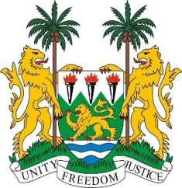
SIERRA LEONE

21st Session of the UPR

GUINEA-BISSAU

23 January 2015

Madam Vice-President,

Sierra Leone warmly welcomes the delegation of Guinea-Bissau and thanks them for their comprehensive national report which provides insight into the progress made since their last review.

My delegation congratulates Guinea-Bissau on the successful holding of presidential and legislative elections in 2014. Sierra Leone commends the efforts to address various human rights challenges, in particular, the setting up of the National Forum of Justice, charged with the reform of the Justice system. Other notable achievements include the adoption of a national action plan for trafficking in persons; the National Policy on Equality and Gender Equity and the setting up of the Children’s Parliament.

However, Sierra Leone notes that, although a number of policies, strategies and plans have been developed to address various aspects of human rights, implementation has been limited by the lack of resources and political and institutional instability. In this connection, Sierra Leone urges Guinea-Bissau to seek international assistance to meet the financial and technical challenges that have impeded the human rights promulgation in the country. To this end, Guinea-Bissau should consider establishing a national human rights institution that is in conformity with the Paris Principles.

Sierra Leone is concerned about the poor performance in the social sectors of health and education and urges the international community to assist Guinea Bissau to address the gaping needs in these sectors.

My delegation has the following recommendations:

- Submit the various overdue relevant treaty bodies.
- Enforce national legislation in rural areas in order to prevent child early and forced marriage.
- Investigate and vigorously prosecute crimes perpetuated against vulnerable groups, such as the disabled and persons with albinism.

Sierra Leone wishes Guinea-Bissau a successful completion to this review process.

Thank you, Madam Vice-President.

